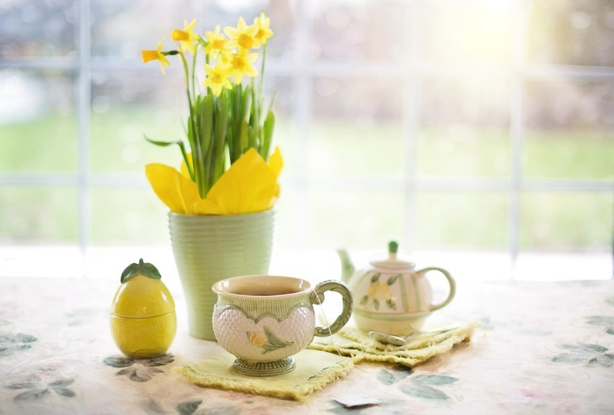

Friendship Teas
St Johns Boxmoor

You are most welcome to join us for a
Vibrant Afternoon of Tea, Fellowship &
Friendship in the Hall at St Johns Church

This event will take place on Wednesday
16th March 2022
From 3:30pm – 5:00pm

Tea and light refreshments will be served

Hear a story – Tell a story – Bring a friend
Make a new friend.

Friendship Tea will be held on the
3rd Wednesday of every month
Our next date is 20th April 2022

For more information, or if you want to assist and be a part this
ministry contact: Sandy Cutts : cuttssandycutts@gmail.com

